**CREATE A SPRING WEB PROJECT USING MAVEN**

**SME Walkthrough**

**src/main/java:**

· The main class SpringLearnApplication.java is inside the package: com.cognizant.springlearn

· The src/main/java folder contains the main source code of the Spring Boot application, including the entry point class and all functional components.

**src/main/resources:**

· application.properties – to define settings like server port, logging level, database URL, etc.

· The src/main/resources folder is used to store configuration and property files required for application setup.

**src/test/java:**

· It contains package : com.cognizant.springlearn

· Uses JUnit testing libraries

· The src/test/java folder contains test cases to validate the application logic and ensure code reliability.

**SpringLearnApplication.java:**

package com.cognizant.spring_learn;

import org.springframework.boot.SpringApplication;

import org.springframework.boot.autoconfigure.SpringBootApplication;

@SpringBootApplication

public class SpringLearnApplication {

public static void main(String[] args) {

System.*out*.println("SpringLearnApplication main method started...");

SpringApplication.*run*(SpringLearnApplication.class, args);

}

}

**SpringLearnApplicationTests.java:**

package com.cognizant.spring_learn;

import org.junit.jupiter.api.Test;

import org.springframework.boot.test.context.SpringBootTest;

@SpringBootTest

class SpringLearnApplicationTests {

@Test

void contextLoads() {

}

}

**Dependencies on pom.xml:**

<dependencies>

<dependency>

<groupId>org.springframework.boot</groupId>

<artifactId>spring-boot-starter-web</artifactId>

</dependency>

<dependency>

<groupId>org.springframework.boot</groupId>

<artifactId>spring-boot-devtools</artifactId>

<scope>runtime</scope>

</dependency>

</dependencies>

**DEPENDENCY HIERARCHY**

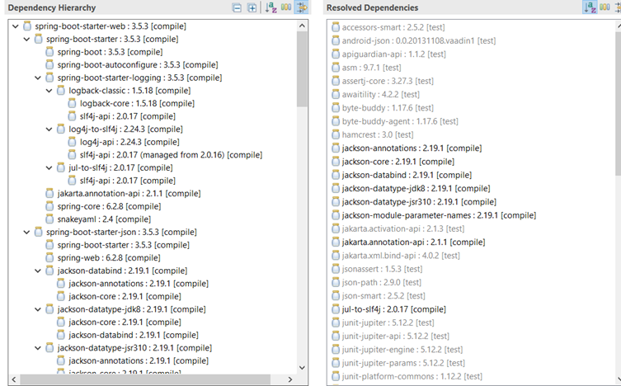

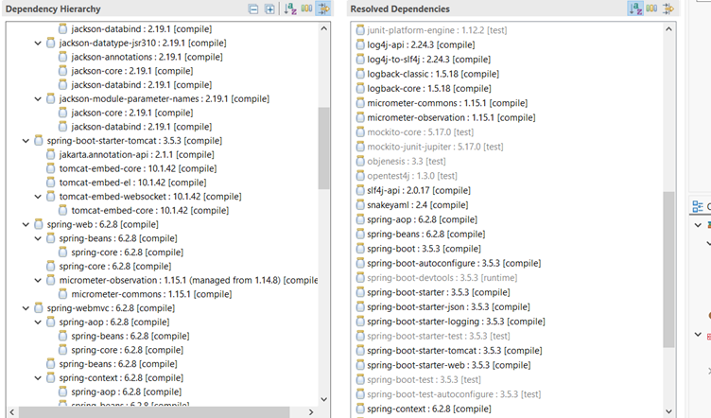

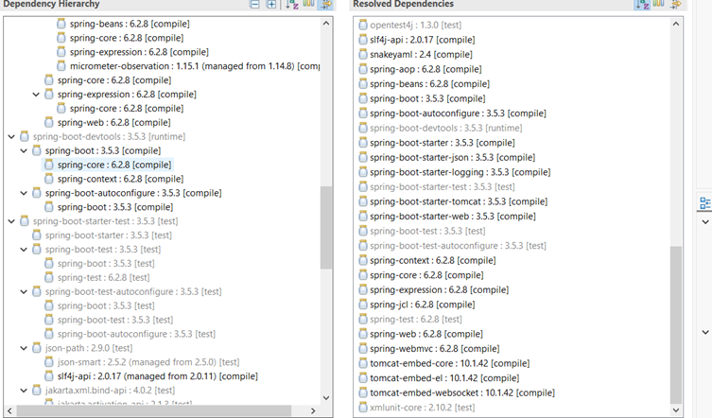

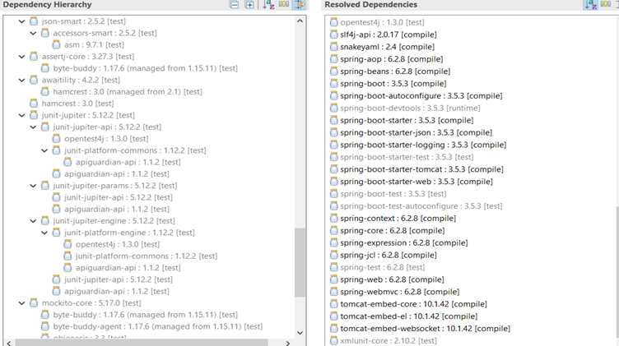

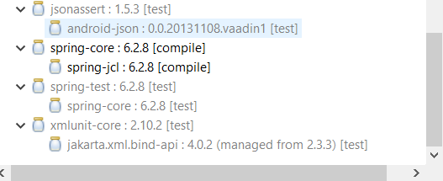

**OUTPUT**

